Group Business | TACT
Job Title | Family Navigator, Family Forward Ayrshire
Department | Family Forward Ayrshire
Name of Post Holder
Reports to (Job Title) | Practice & Supervision Lead
Organisation Chart
(showing job in context of Group Business)
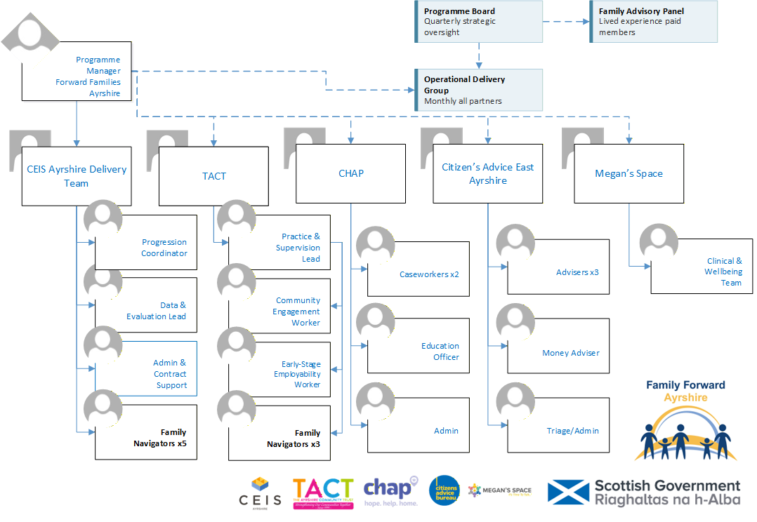

Location
Ayrshire (community-based role in one of North, East or South Ayrshire; or across the area)
Contract
Fixed-term until March 2027 (renewal subject to future funding)
Hours
Full-time
Salary
£28,400
Employer
TACT

Job Context
(a description of the job in the context of where it fits in the overall structure of the Group Business and beyond if required).
Family Forward Ayrshire is a whole-family support programme across North, East and South Ayrshire, funded by the Scottish Government's Whole Family Support Third Sector Delivery Fund. The programme is delivered by a partnership of five organisations — CEIS Ayrshire (lead), TACT, CHAP, Citizens Advice East Ayrshire and Megan's Space — and will reach 431 families, securing £1.275m–£1.5m in direct financial gains and supporting 120–135 parents into work, better-paid work or accredited training. Every intensive family has one named Family Navigator and one co-produced plan; specialists work on shared caseloads inside that plan, not through referral chains. This post is held by CEIS Ayrshire (5 posts) or TACT (3 posts). Both employers deliver an identical role within one integrated operating model: joint induction, shared tools, shared quality standards and shared caseload allocation. The employing organisation provides line management, but the Navigator's operational accountability is to the programme's shared standards. All posts are required to work within the programme's non-negotiable ways of working: shared caseload (specialists join the family's plan rather than receiving referrals); voluntary engagement only; trauma-informed practice; and same-day recording in the shared case management system.
Job Purpose
(a description of what the job entails and why it exists).
To be the one trusted person who stays with each family from first contact to sustained change. The Navigator holds the relationship, conducts the whole-family assessment, co-produces and maintains the single-family plan, coordinates every specialist around it, removes practical barriers fast through the Family Support Fund, and keeps the whole-family view when everyone else is looking at their piece. The relationship is the intervention; everything else in this job exists to serve it.
Family Navigators will be assigned to one of the Local Authority Areas with either CEIS Ayrshire or TACT or will work across the whole area with CEIS Ayrshire.
Assignment and Review of Work
(who the post holder reports to, and who will review their work, how and when this will happen).
Navigators employed by CEIS Ayrshire report to the Programme Manager. Navigators employed by TACT report to TACT line management, within the programme's integrated operating model. Work is generated by the programme's shared caseload allocation protocol. Caseload weighting (typically 15–18 active families at any time) is reviewed monthly by the Programme Manager with all Navigators. Supervision is monthly; formal performance review is bi-annual.
Key Deliverables
(a numbered list of the major KPIs and KDIs for the job).
- Make first contact with each allocated family within three working days of referral — warm, honest, unhurried, on the family's terms, usually at home.
  - Conduct the whole-family assessment across five domains (money, home, health & wellbeing, children, work & learning) as a conversation, completing WEMWBS baselines as standard.
  - Co-produce the family plan, opening with the family's own words, and keep it current — every intensive plan updated at least every 21 days.
  - Respond to missed appointments with warmth within 48 hours; flex pace, place and people to fit the family, not the service.
  - Allocate plan strands to specialists through the case-allocation protocol; chase stalled strands peer-to-peer within a week; tell the family the truth about delays.
  - Hold the commitments log — anything promised to the family, by anyone, is recorded and kept.
  - Watch for pattern across strands, including child-level drift and fragmented safeguarding concerns; convene case calls rather than letting plans drift.
  - Ensure the first-month income review happens for every intensive family — booked at assessment, not when a problem surfaces.
  - Deploy the Family Support Fund within delegation (≤£250 per instance) fast and without ceremony; every award linked to a plan action.
  - Bring the Progression Coordinator into the plan personally when the family signals readiness — never as a referral; ensure the better-off calculation happens before any employment change.
  - Manage step-down by agreement, keep the open door genuinely open, and complete 4–6 week and 6-month follow-ups on schedule.
  - Act on safeguarding concerns the same day under the relevant area's procedures; remain alongside families through statutory processes where safe and appropriate.
- Record same day in the shared case system; administer WEMWBS at 3 and 6 months, honestly dated.
Responsibility for Resources (direct or indirect)
(both human and other resources, description of other resources (if any).
Number of people: N/A (no direct line management responsibility)
Their Job types: N/A
Budgets: Family Support Fund: delegation up to £250 per instance (amounts above £250 escalate to Programme Manager)
Communications and Working Relationships
Internal
- Programme Manager (CEIS posts) / TACT line management (TACT posts)
- Fellow Navigators — peer accountability, case calls, shared induction cohort
- Progression Coordinator — warm introduction into family plans
- Data & Evaluation Lead — recording standards and WEMWBS administration
External
- Families on caseload — the primary relationship
- CHAP welfare rights workers — shared caseload allocation
- CAB East Ayrshire advisers — shared caseload allocation
- Megan's Space wellbeing practitioners — shared caseload allocation
- Referral partners: schools, health visitors, GPs, community organisations
- DWP work coaches — maintained on voluntary-engagement basis
- • Family Advisory Panel — values-based selection, co-design
Job Requirements
(qualifications, skills and experience – for job not specific job holder.

 | Essential | Desirable
1 EDUCATION / QUALIFICATIONS
Relevant professional qualification (social work, community work, health, advice or related field), or equivalent experience — lived experience of navigating services is explicitly valued and may be evidenced in place of formal qualifications |  | ü
2 EXPERIENCES
Demonstrable ability to build trust quickly with people in difficult circumstances and hold it over months — evidenced through work, volunteering or lived experience | ü
Experience of working alongside families or adults facing poverty, crisis or multiple service involvement | ü
Sound safeguarding judgement and willingness to act the same day | ü
Experience of whole-family or key-worker models |  | ü
WEMWBS or validated wellbeing measurement experience (training provided) |  | ü
Community connections in North, East or South Ayrshire |  | ü
3 KNOWLEDGE
Working knowledge of the benefits, housing and employability landscape sufficient to know when to bring in a specialist | ü
4 SKILLS AND ABILITIES
Ability to coordinate other professionals without needing to control them, and to challenge a stalled service on a family's behalf | ü
Comfort working at the family's pace: patience with non-linear progress, no rescuing, no rushing | ü
Organised and reliable: able to hold 15–18 active plans, a commitments log and same-day recording without dropping threads | ü
Full driving licence and access to transport, or demonstrable ability to meet a three-area home-visiting requirement by other means | ü
5 PERSONAL
Commitment to voluntary engagement — no conditionality or compliance monitoring in any aspect of the role | ü
Commitment to trauma-informed practice and willingness to complete joint programme training in Months 1–2 | ü
Honest, reliable and warm: able to keep the small promises that trust is built on | ü

Signature of Postholder
Signature of Manager
Job Description Compiled by
BH
Date Completed/Revised
17/08/2026
Job description should be reviewed annually v3b 17/08/2026

